# ABSTRACT:

# Unlike classroom education, immediate feedback from the students is quite difficult in online classes. So, in order to get feedback from them or we can say in order to detect their confusion level, a single-channel EEG headset sensor can be used. This sensor is good enough for detecting students’ mental states and simple enough to use at home with very little training. Its signals are collected from students watching educational video clips. We trained and tested classifiers to detect when the student is confused while watching the course material. The classifier has a comparable performance to human observers observing body language in predicting students’ confusion. We found accuracy of our model for using EEG to distinguish when a student is confused or not. This project promises deployable EEG devices being able to capture tutor relevant information.

# 

INTRODUCTION

From the year 2020, people’s lives have been drastically affected due to the pandemic. We are not only physically affected but our profession, lifestyle, mental health everything is affected & so is the case with students. They are left with no option other than taking online classes.

In offline education, the teacher can judge whether the student is able to grab everything by seeing his/her body language or expressions but the same thing is not possible in online classes. As a result, classes became less-interactive. Also, there are no problem solving discussions among the students leaving them confused in several topics.

Hence, in this project our focus is to detect student’s confusion level by using electroencephalography (EEG) input from a commercially available device as evidence of students’ mental states.

The recent availability of simple, low-cost, portable EEG monitoring devices now makes it possible to take the technology from the lab into institutions. The NeuroSky ``MindSet”, for example, is an audio headset equipped with a single-channel EEG sensor. It measures the voltage between an electrode that rests on the forehead and electrodes in contact with the ear. Unlike the multi-channel electrode nets worn in labs, the sensor requires no gel or saline for recording and therefore requires much less expertise to position. Even with the limitations of recording from only a single sensor and working with untrained users, it is found that the MindSet distinguished two fairly similar mental states (neutral and attentive) with 86% accuracy. MindSet has been used to detect reading difficulty and human emotional responses.

We propose that institutes provide EEG device for students. In return, they would get feedback on students' EEG brain activity or confusion level while students attend online classes. As a result, the teacher can get feedback from an entire class & hence can improve their teaching accordingly. Thus, we are hopeful that our proposal is incorporated in institutes’ facilities which could enhance student’s learning.

**METHOD USED : 1D-CNN:**

Convolutional neural networks are another type of commonly used neural network.Neural networks are modeled after our brains. There are individual nodes that form the layers in the network, just like the neurons in our brains connect different areas.

A convolutional neural network is a specific kind of neural network with multiple layers. It processes data that has a grid-like arrangement then extracts important features.

The convolutional neural network algorithm's main purpose is to get data into forms that are easier to process without losing the features that are important for figuring out what the data represents. This also makes them great candidates for handling huge datasets.

A big difference between a CNN and a regular neural network is that CNNs use convolutions to handle the math behind the scenes. A convolution is used instead of matrix multiplication in at least one layer of the CNN.

CNNs work by applying filters to the input data. CNNs are able to tune the filters as training happens. That way the results are fine-tuned in real time.

Since the filters can be updated to train the CNN better, this removes the need for hand-created filters. That gives us more flexibility in the number of filters we can apply to a data set and the relevance of those filters.

CNNs consist of a set of layers that can be divided into:

1) Convolutional layers that extract features from the input data via convolution operations.

2) Pooling layers that merge some features in order to reduce the number of them.

3) Dense or fully connected layers that classify each pattern according to the previously extracted features.

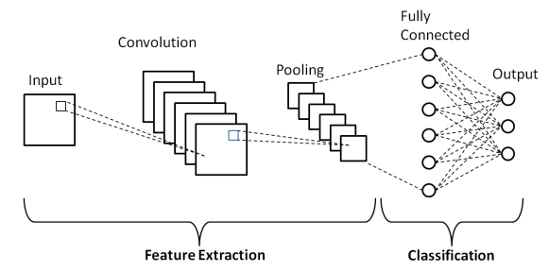

## 

## **DATABASE:**

The data contains EEG signals of college students while they were watching educational video clips. There are 2 types of video clips. First category of videos contain the topics with which students are quite familiar like introduction of basic algebra or geometry. Second category contains topics which could be confusing for them like Quantum Mechanics. There were a total 20 videos, 10 in each category. Each video was 2 minutes long. The two-minute clip was chopped in the middle of a topic to make the videos more confusing.

Data is collected from 10 students. One student was removed because of missing data due to technical difficulty. An experiment with a student consisted of 10 sessions. 5 videos from each category were randomly picked & the sequence of their presentation was also randomized so that the student could not guess the video hence avoiding any kind of predefined confusion level. In each session, the student was first instructed to relax their mind for 30 seconds. Then, a video clip was shown to the student where he/she was instructed to try to learn as much as possible from the video. After each session, the student rated his/her confusion level on a scale of 1-7, where 1 corresponded to the least confusing and 7 corresponded to the most confusing. Additionally, there were three student observers watching the body-language of the student. Each observer rated the confusion level of the student in each session on a scale of 1-7.

The students wore a wireless single-channel MindSet that measured activity over the frontal lobe. The MindSet measures the voltage between an electrode resting on the forehead and two electrodes (one ground and one reference) each in contact with an ear. More precisely, the position on the forehead is Fp1 (somewhere between left eyebrow and the hairline).

To collect the following signal streams, NeuroSky’s API was used:

1. The raw EEG signal, sampled at 512 Hz

2. An indicator of signal quality, reported at 1 Hz

3. MindSet’s proprietary “attention” and “meditation” signals are said to measure the user’s level of mental focus and calmness, reported at 1 Hz

4. A power spectrum, reported at 8 Hz, clustered into the standard named frequency bands: delta (1-3Hz), theta (4-7 Hz), alpha (8-11 Hz), beta (12-29 Hz), and gamma (30-100 Hz).

* Sampling Frequency: 512 Hz
* Number of Classes: 2
* Number of Samples in each classes: 49-not confused (Label 0), 51-confused(Label 1)
* Total Number of Samples: 100

**About some modification in number of samples or in database :**

The column named “raw” was considered and a new dataset was created using this column. This new dataset was then separated into two excel sheets namely confused and not_confused so that they can be used for designing 1D-CNN model for prediction of mental state of students as confused or not confused.

There were 51 samples for class “confused” and 49 samples for class “not confused”. Due to outliers some data points were removed which resulted in 46 samples for confused class and 44 samples in not confused class.

As the dataset is not balanced , resampling of data is done by which 500 samples of each class are generated.

**Training testing split ratio: 80:20**

Number of samples in train set: 800

Number of samples in test set: 200

##### **Deep Learning architecture used**

##### 

##### Table 1. Detailed parameters of the proposed 1D-CNN model

| **Type of Layer** | **Output Shape** | **Other Parameters of each layer** |
| --- | --- | --- |
| Conv1DBatch NormalizationMax Pooling 1DActivation | (109;80)(109;80)(36;80)(36;80) | Filters - 80, Kernel Size - 4, Pool Size – 3, Activation - Relu |
| Conv1DBatch NormalizationMax Pooling 1DActivation | (35;40)(35;40)(11;40)(11;40) | Filters - 40,Kernel Size - 2, Pool Size – 3, Activation - Relu |
| FlattenDenseDenseOutput Layer | (440)(5)(5)(2) | Units - 5, Activation – ReluUnits - 5, Activation – Relu Units - 2, Activation – SoftMax |

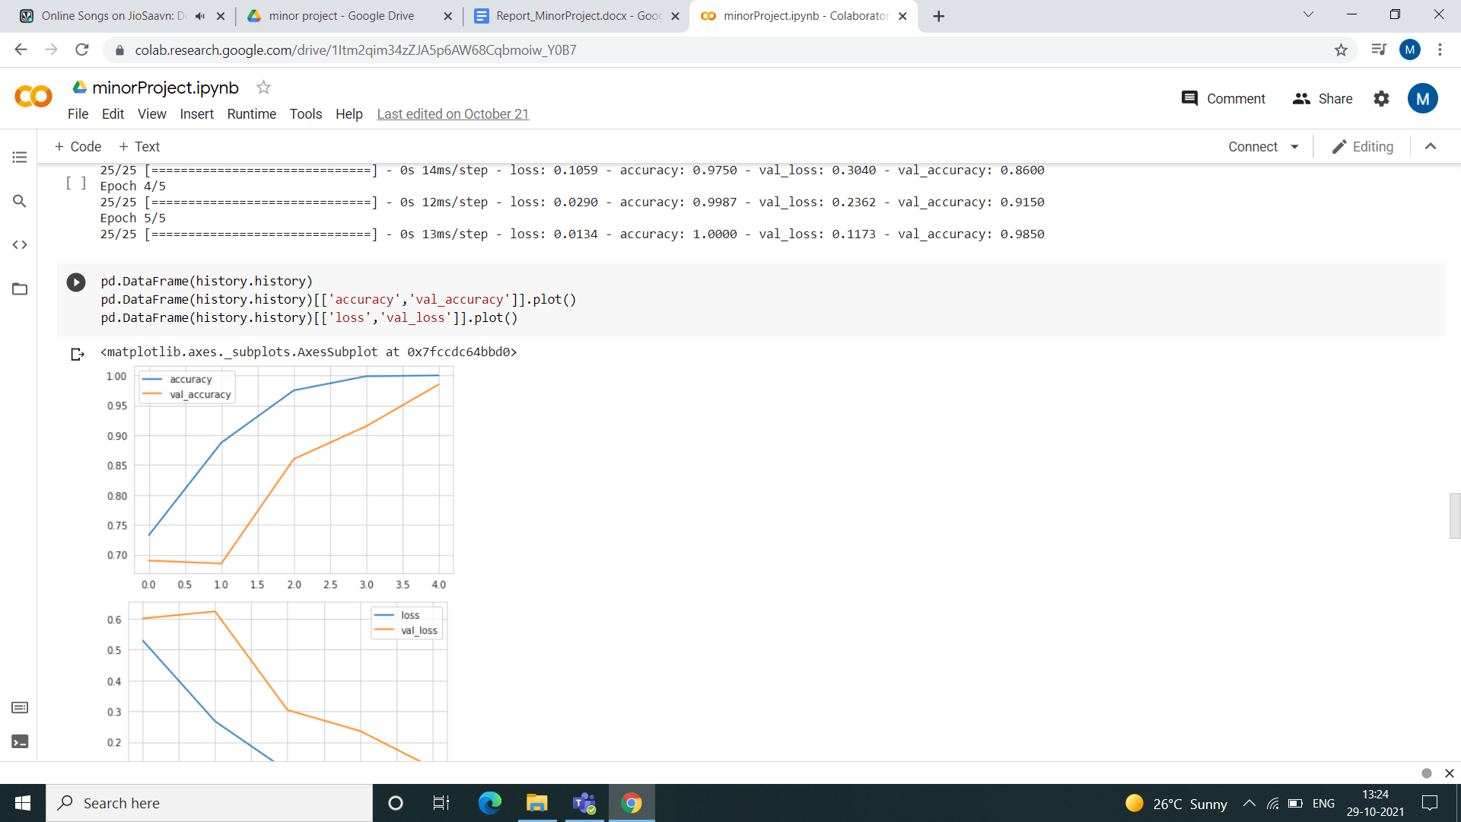

Figure 1. Training and validation accuracy of Model



Figure 2. Training and validation loss of Model

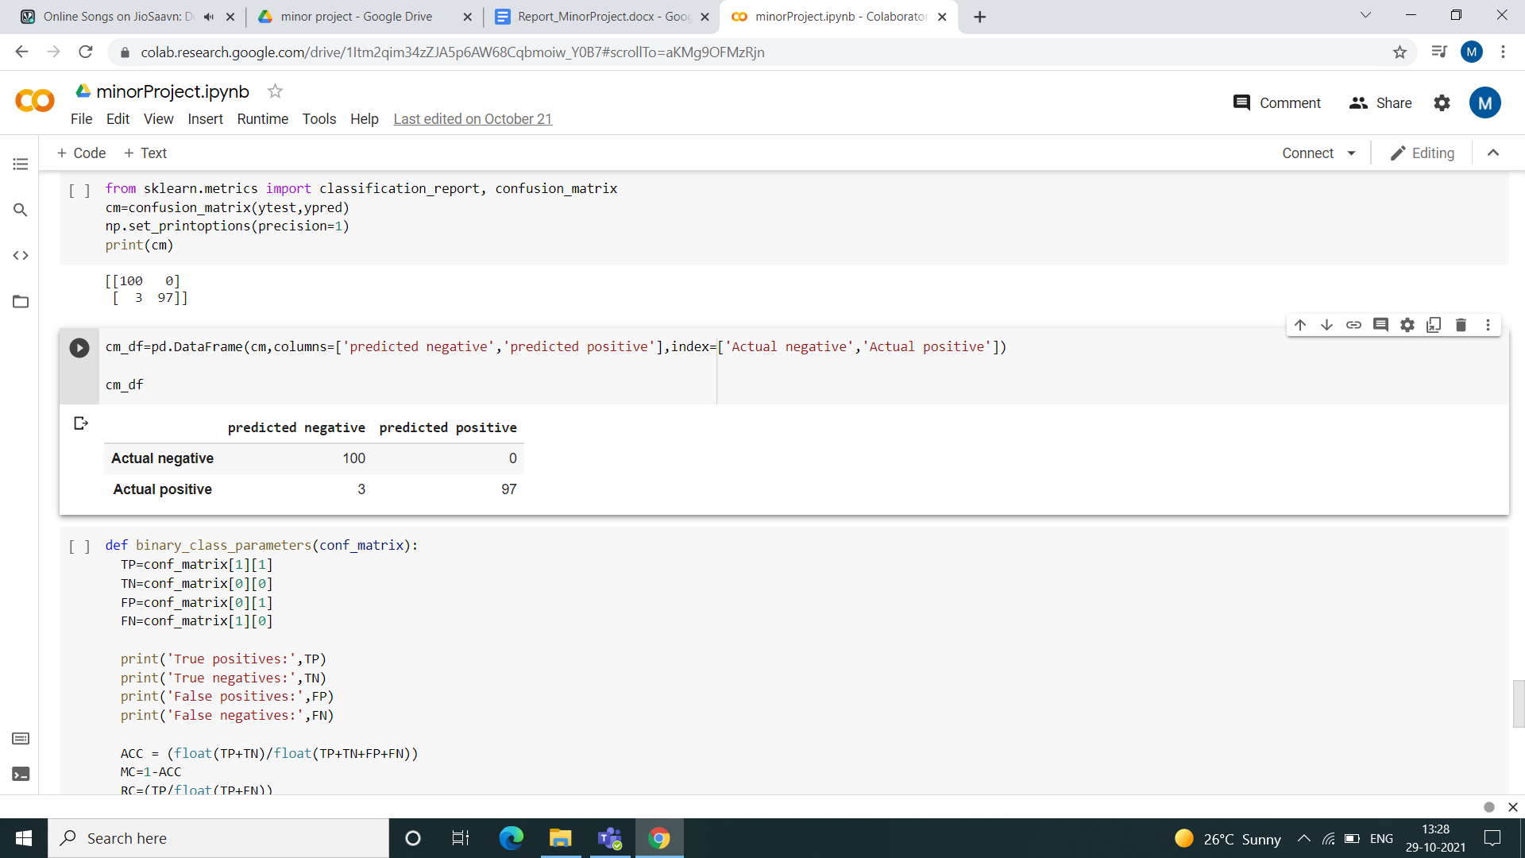

Figure 3. Confusion Matrix of Model

**RESULT**

Maximum accuracy obtained after training the dataset using proposed 1D-CNN model was 98.5%. Confusion matrix was plotted and various parameters were obtained using this confusion matrix to evaluate the model.

**Parameters are as follows :**

True positives: 97

True negatives: 100

False positives: 0

False negatives: 3

1. Accuracy : 0.985

2. Mis -Classification : 0.015000000000000013

3. Sensitivity recall : 0.97

4. Specificity : 1.0

5. Precision : 1.0

6. f_1 Score : 0.9847715736040609

CONCLUSION:

In this project, we worked on the dataset of students’ EEG brain activity while they learn from educational video clips. We trained and tested classifiers to detect when a student was confused. We used EEG signals to distinguish whether a student is confused. The classifier has comparable performance to human observers observing body language in predicting students’ confusion.

So, if the project is implemented on a bigger level like during online classes or the platforms which offer online courses, we are hopeful that this would help both teachers & students hence improving the quality of the content delivered.

One point which we want to highlight is not every student is willing to share their brain activity data due to some privacy concerns. In that case, they are advised to not use EEG.

## **REFERENCES**

* + - 1. Wang, H., Li, Y., Hu, X., Yang, Y., Meng, Z., & Chang, K. M. (2013, June). Using EEG to Improve Massive Open Online Courses Feedback Interaction. In AIED Workshops(http://www.cs.cmu.edu/~kkchang/paper/WangEtAl.2013.AIED.EEG-MOOC.pdf)
      2. https://www.kaggle.com/wanghaohan/confused-eeg